- ANALYSIS OF TRANSACTIONS USING ACCOUNTING EQUATION 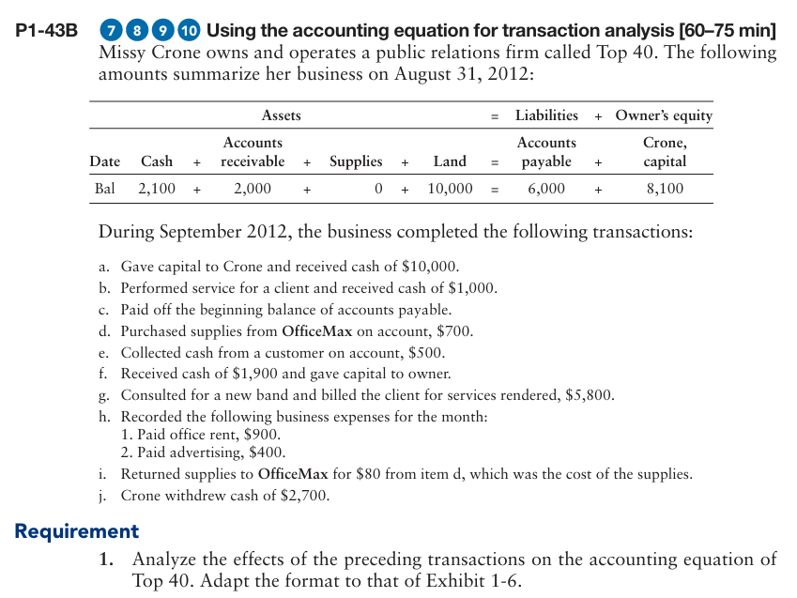

- RECORDING TRANSACTIONS, POSTING IN LEDGER AND PREPARING THE TRIAL BALANCE
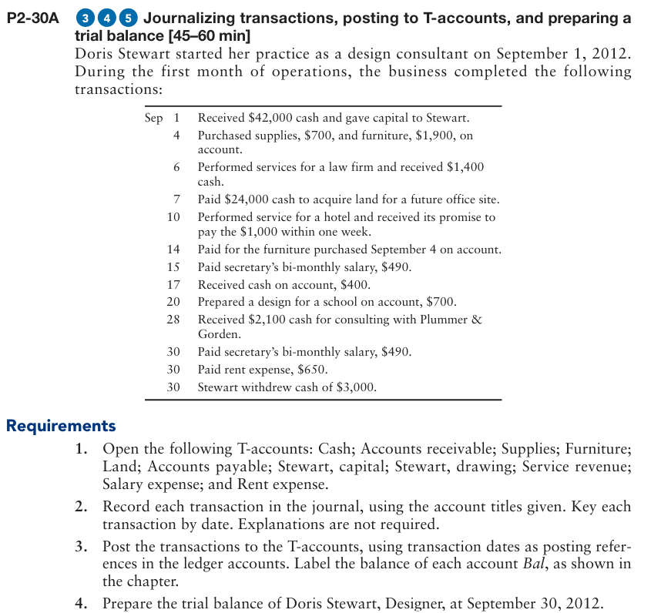

- CORRECTING A TRIAL BALANCE WHICH IS NOT BALANCING
